Personas: (created by Ayushi)
Persona 1:
Jacob Thompson – Volunteer Coordinator


Goals:
- Build an efficient volunteer assignment system
- Reduce volunteer no-show rates
- Improve overall volunteer satisfaction and retention
Frustrations:
- Time-consuming manual scheduling processes
- Poor communication leading to volunteer no-shows
- Difficulty in maintaining an up-to-date volunteer database
Additional Points:
- Values clear, efficient communication
- Interested in engaging younger volunteers

Age: 35
Background: Volunteer coordinator at Helping Hands Nonprofit
Needs:
- Streamlined volunteer scheduling and communication
- Easy tracking of volunteer hours and activities

Persona 2:
Sofia Martinez – Student Applicant

Goals:
- Successfully apply for a study abroad program
- Minimize financial burden through scholarships
- Receive clear guidance through each application step
Frustrations:
- Overwhelming application process with multiple steps
- Unclear eligibility requirements for study programs
Additional Points:
- Prefers a mobile-friendly interface
- Interested in virtual tours of host universities before applying



Age: 21
Background: 3rd-year Business student at Conestoga College
Needs:
- Find a cost-effective program that fits her major
- Apply with minimum hassle and paperwork

Persona 3:

Isabella Russo – Volunteer Coordinator


Age: 32
Background: Works for a local nonprofit organization
Needs:
- Enhance volunteer coordination and engagement

Goals:
- Organize events that engage volunteers
- Ensure effective communication with volunteers
- Build a strong community impact
Frustrations:
- Limited volunteer availability and time commitments
- Difficulty in maintaining regular volunteer engagement
- Lack of specialized skills among volunteers
Additional Points:
- Prefers email and messaging apps for communication
- Values personal relationships with volunteers
- Attends workshops on volunteer management

Created by Sagar

1.Erd

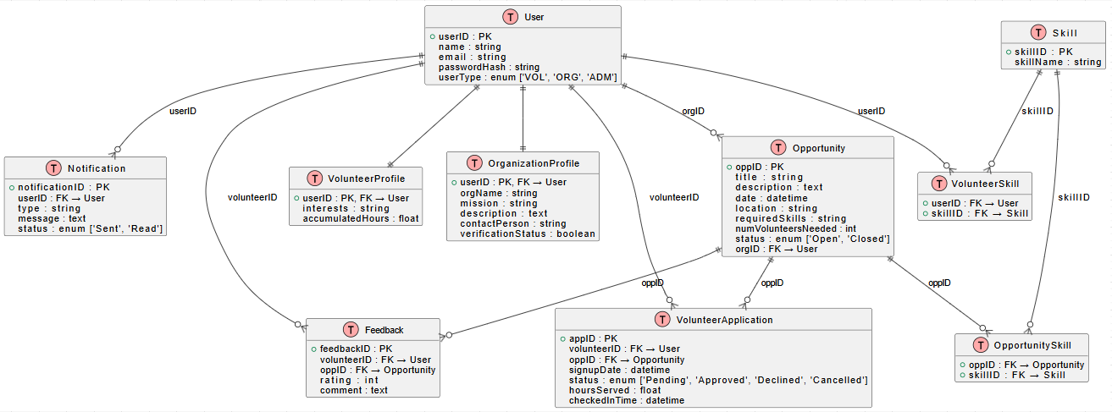

2.Class diagram
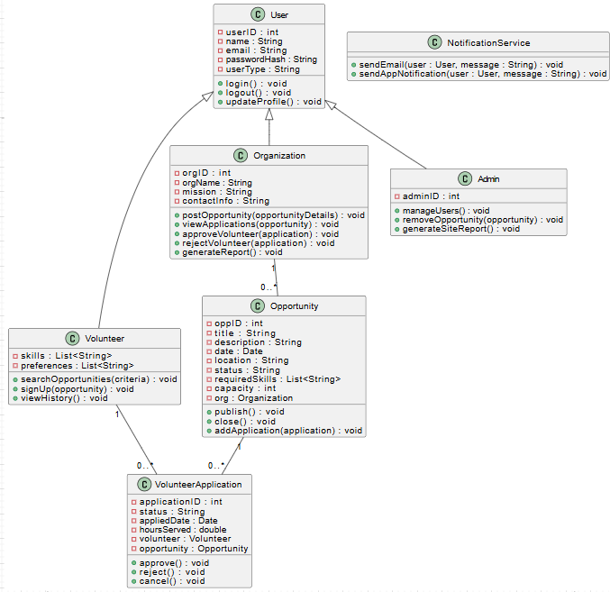

3.activity diagram (Created by Shivam)
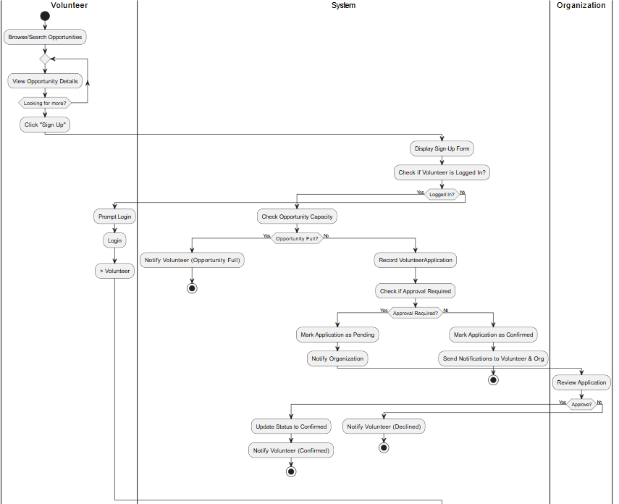

(Created by Ayushi)
Prototype: Screen 1 & 2
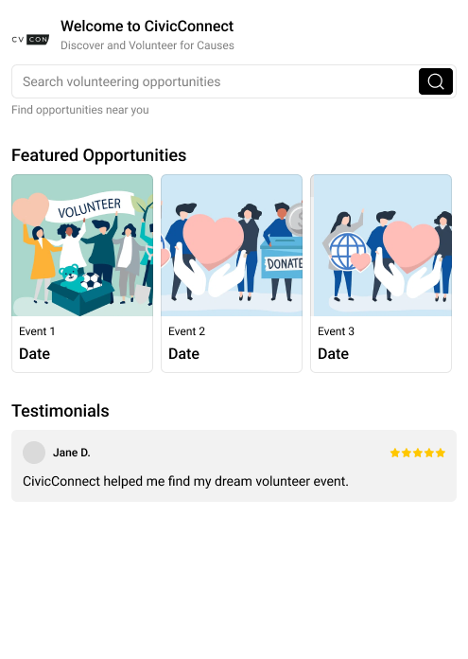
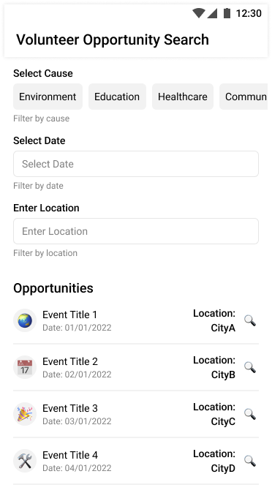
Screen 3:
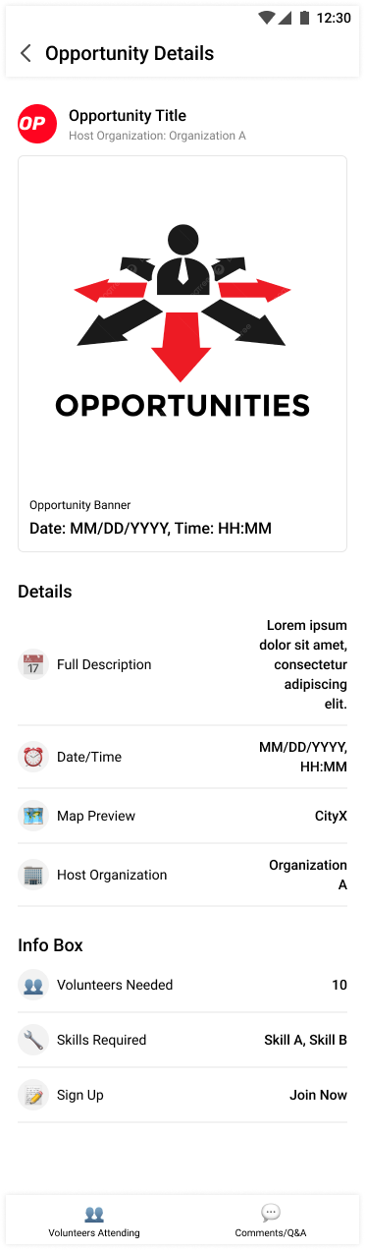

Screen 4 & 5:
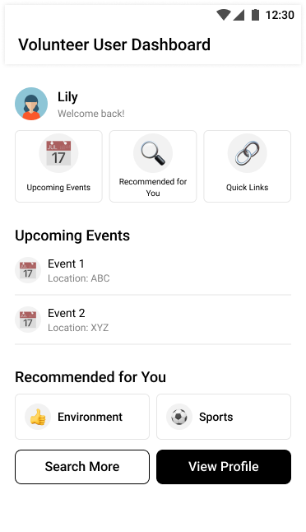
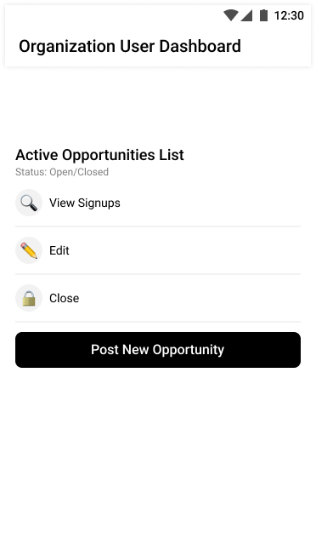
Screen 6:
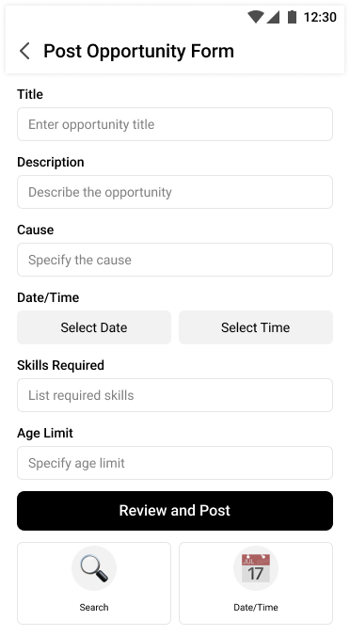

Screen 7:
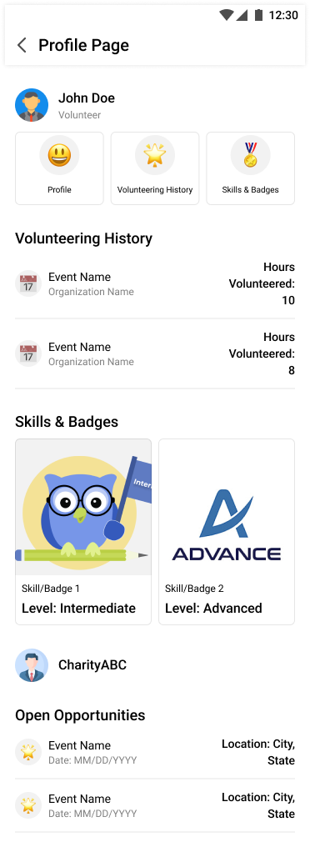

Screen 8:
